**University of Michigan – Dearborn**

**Department of Computer and Information Science**

**CIS 150/150L – Fall 2014**

Lab 1

Srinivas Simhan

09/15/14

**Table of Content**

1. Question 1 3
   1. Screenshot 3
   2. Source Code 3
   3. The use of #include<iostream> 3
   4. The use of system(“pause”) 3
2. Question 2 4
   1. Source Code 4
   2. Software Testing Table 5
   3. Screenshots 6
3. Question 3 8
   1. Screenshot 8
   2. Source Code 9
4. **Question 1**
   1. **Screenshot**

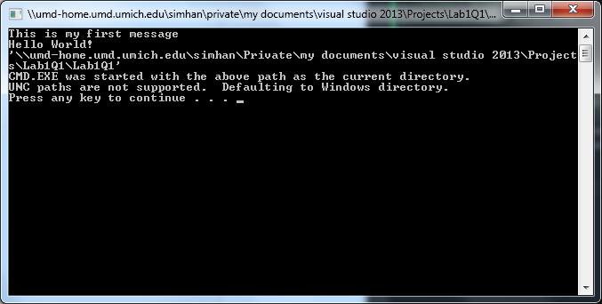

* 1. **Source Code**

//This is a hello world program.

//Author: Srinivas Simhan

//Creation Date: 09/15/2014

#include <iostream>

using namespace std;

int main()

{

cout << "This is my first message" << endl;

cout << "Hello World!" << endl;

system("pause");

return 0;

}

* 1. **The use of #include <iostream>**

Yes, the <iostream> is a library for input and outputs. If you comment out the line, then it will treat the code as though the library was never added, therefore inputs and outputs are not recognized.

* 1. **The use of system(“pause”)**

The use of the “pause” is to halt the command prompt screen in order to view the operation taking effect. By commenting out the line, it skips over the pause, therefore not allowing the view to see what operation is occurring.

1. **Question 2**

**2.1 Source Code**

// File: coins.cpp

// Determines the value of a coin collection

#include <iostream>

#include <string>

using namespace std;

int main()

{

string name; // input: niece’s first name

int pennies; // input: count of pennies

int nickels; // input: count of nickels

int dollars; // output: value of coins in dollars

int change; // output: value of coins in cents

int totalCents; // total cents represented

// Read in your niece’s first name.

cout << "Enter your first name: ";

cin >> name;

// Read in the count of nickels and pennies.

cout << "Enter the number of nickels: ";

cin >> nickels;

cout << "Enter the number of pennies: ";

cin >> pennies;

// Compute the total value in cents.

totalCents = 5 * nickels + pennies;

// Find the value in dollars and change.

dollars = totalCents / 100; // integer division

change = totalCents % 100;

// Display the value in dollars and change.

cout << "Good work " << name << '!' << endl;

cout << "Your collection is worth "

<< dollars << " dollars and "

<< change << " cents." << endl;

system("pause");

return 0;

}

2.2 **Software Testing Table**

|  |  |  |  |
| --- | --- | --- | --- |
| Reason for Test Case | Input Values | Expected Output | Observed Output |
| 1. Case where we do not have pennies | Nickels: 60,  Pennies: 0 | 3 dollars and 0 cents | 3 dollars and 0 cents |
| 1. Case where we do not have nickels | Nickels: 0,  Pennies: 60 | 0 dollars and 60 cents | 0 dollars and 60 cents |
| 1. Case where we have half as many pennies as nickels | Nickels: 60,  Pennies: 30 | 3 dollars and 30 cents | 3 dollars and 30 cents |
| 1. Case where we have half as many nickels as pennies | Nickels: 30,  Pennies: 60 | 2 dollars and 10 cents | 2 dollars and 10 cents |

2.3. **Screenshots**

Example: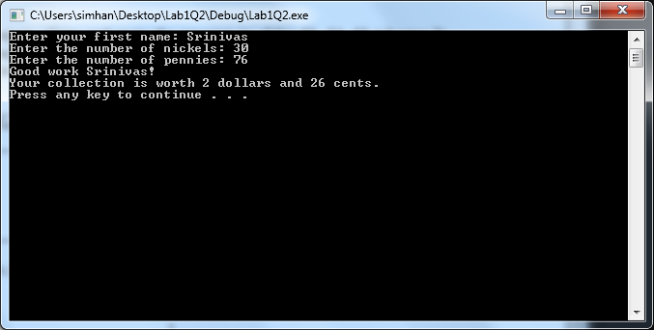

Case a:

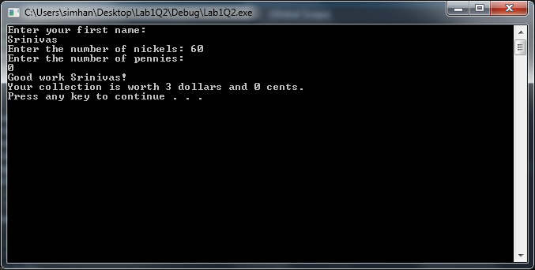

Case b:

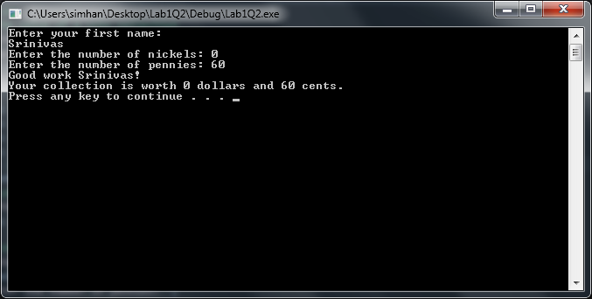

Case c:

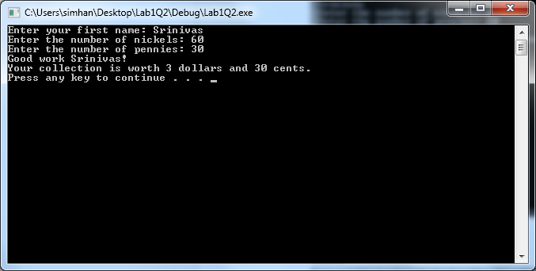

Case d:

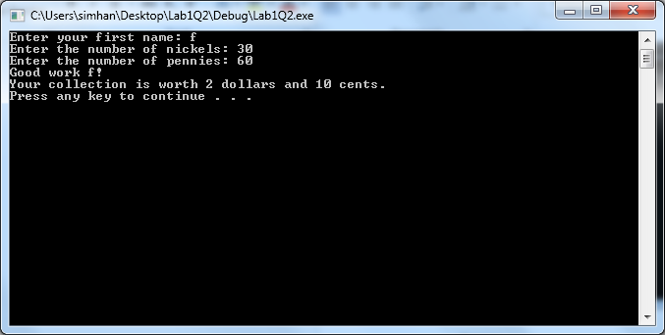

1. **Question 1**
   1. **Screenshot**

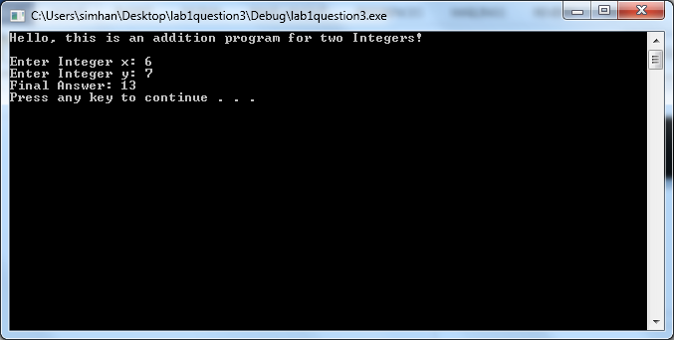

* 1. **Source Code**

//This is an addition program for two Integers.

//Author: Srinivas Simhan

//Creation Date: 09/15/2014

#include <iostream>

using namespace std;

int main()

{

cout << "Hello, this is an addition program for two Integers! " << endl;

cout << "" << endl;

// Declare three variables x, y, and z of type in

int x; // input: x

int y; // input: y

int z; // output: z

// Display a message using cout asking the user to enter a first integer

// Use cin to prompt the user for a value for x

cout << "Enter Integer x: ";

cin >> x;

// Display a message using cout asking the user to enter a second integer

// Use cin to prompt the user for a value for y

cout << "Enter Integer y: ";

cin >> y;

// write a statement that assign x + y to z

z = x + y;

cout << "Final Answer: " << z << endl;

system("pause");

return 0;

}